ĐỀ CƯƠNG ÔN TẬP TIẾNG ANH 6
HỌC KỲ II NĂM HỌC 2018 - 2019
I. LISTEN:
1. Listen to an interview with an Olympic swimming champion – Jackson Avery. Decide if the statements are true (T) or false (F). Circle T or F. You will listen TWICE.
1. Jackson won in the 500-metre competition. | T | F
2. Jackson went running every day before the event. | T | F
3. Jackson ate a normal diet. | T | F
4. Jackson didn’t have a trainer. | T | F
5. Jackson needed to balance between training and rest. | T | F
2. Listen to the conversation between a customer and a receptionist at the gym. Answer the questions with NO MORE THAN TWO WORDS AND/OR A NUMBER. You will listen TWICE.
1. What sports are they talking about?
________________________________
2. What class level is the customer interested in?
________________________________
3. What class time did the customer choose?
________________________________
4. What should the customer wear?
________________________________
5. What does the gym provide?
________________________________
3. Listen to the conversation between Tony and Claudia about a robot exhibition show. Fill each of the gaps with NO MORE THAN TWO WORDS. You will listen TWICE.
Robots | Size and shape | Functions
Omnibot | as small as a (2) ___________ | works as a (1) ___________
Nedo | as big as a human | moves (3) ___________ in natural disasters
(4) __________ | as big as a doll | tells you when the door is opened  records and (5) ___________ to your parents
4. Listen to a teacher giving some tips to keep the air clean. Fill each of the gaps with ONE WORD. You will listen TWICE.
The teacher gives (1) ____________ tips,
(2) ____________ tips,
and (3) ____________ tips.
He tells students to use gas at home instead of (4) ____________ wood.
He also advises students to avoid (5) ____________ that smoke.
5. Listen to the interview with John Adams, a travel writer. Circle the best answer A, B or C. You will listen TWICE.
1. How many countries has John been to?

A. 15 | B. 50 | C. 200

2. What does John say about Ha Noi?

A. It has everything.
B. Its nightlife is exciting.
C. Its food is great.

3. What is John’s favourite city?

A. New York
B. Pagan
C. Bangkok

4. John says Pagan is the best place to ___________.

A. see historic temples | B. meet people | C. see the sun rise

5. What does John say about Angkor Wat?

A. It has more tourists than Pagan.
B. It is the most impressive.
C. It has more temples than Pagan.
II. READ
1. Read the following passage about Michael Jordan. Circle A, B or C to answer each question.
Michael Jordan was born on February 17, 1963. He is considered one of the best basketball players ever. He led the Chicago Bulls to six National Basketball Association championships, and won the NBA's Most Valuable Player Award five times.
Jordan started studying at the University of North Carolina (UNC) in 1981. He soon became an important member of the school's basketball team. In 1982, with Jordan scoring the final basket, the team defeated Georgetown University and became the champion. He was the College Player of the Year in 1983 and in 1984.
In 1984, Jordan became a member of the U.S. Olympic basketball team. The team won the gold medal that year.
1. What team did Michael Jordan play for?
A. Chicago Bulls
B. National Basketball Association
C. Georgetown University
2. How many times did Michael Jordan win the title “College Player of the Year”?

A. Six times | B. Five times | C. Two times

3. When did Michael Jordan start playing for the University of North Carolina?

A. 1963 | B. 1981 | C. 1984

4. What does “the team” in paragraph 2 refer to?

A. University of North Carolina
B. Georgetown University
C. College Player

5. What is the best title of this passage?

A. Michael Jordan: life and career
B. Michael Jordan: the best basketball player
C. Michael Jordan: a professional basketball player
2. Read the passage about Tina’s dream house. Decide if the statements are true (T) or false (F). Circle T or F.
My dream home will be a modern house. The house will be hidden in the forest. There is a gate which is always locked, and you have to talk to me to get in.
Inside the basement will be an average size theatre room. My house will also have an indoor pool. It will also have five floors, and in one floor is a gaming room for me and my brothers and my friends. On the third floor is my room. It is a good place for me to relax.
My dream home also has a lift so it is easier to get to the floors but the house will still have stairs if you want to use them.

1. Tina’s dream house will be traditional. | T | F
2. Getting to her house will take time. | T | F
3. There will be a medium theatre in her house. | T | F
4. Her room is also for playing with friends. | T | F
5. The lift makes it less difficult to get to the floors. | T | F
3. Read the following passage about crazy sports. Fill each of the gaps with NO MORE THAN THREE WORDS.
CRAZY SPORTS
Royal Soccer
Two soccer matches are held every year in a small village in England. The teams include everyone in the village. There is no specific rule. Just be careful not to kill anyone! We don’t know when the game started.
Chess Boxing
This game is popular in Finland. You need to be both smart and strong, because players play chess and then box against each other. There are 11 rounds. Winning comes from either a checkmate or a knockout. This game was first seen in a 1991 movie.
Cheese Chase
This game is held in a small corner of the British Isles. It involves 20 competitors chasing a block of cheese down the hill. Whoever gets the cheese wins. The game is at least 200 years old.
Sports | Where? | How to play? | Origin?
Royal Soccer | England | no (2) ___________ | unknown
Chess Boxing | (1) ___________ | combination of chess and  (3) ___________ | since 1991
Cheese Chase | British Isles | chase a (4) ___________ down the hill | since (5) ___________ years ago

III. WRITING
1. What do you say in these situations? Write the sentences, using imperatives.
Here is an example.
0. Your friends are making a lot of noise, and you want them to stop.
Answer: 0. Please, stop making noise.
1. The cat is scratching the carpet, and you want it to stop.
_____________________________________________
2. The teacher wants her students to close their books.
_____________________________________________
3. The teacher reminds students to do homework.
_____________________________________________
4. The mother tells the boy to bring his umbrella.
_____________________________________________
5. You tell your friend not to copy your homework.
_____________________________________________
2. For each question, complete the second sentence so that it means the same as the first. Use the word in brackets. You CANNOT change the form of the word given. Write NO MORE THAN THREE WORDS.
1. Peter hasn’t been to Viet Nam.
Peter ____________________ to Viet Nam. (NEVER)
2. Sydney is not as hot as Rio de Janeiro.
Rio de Janeiro is ____________________ Sydney. (HOTTER)
3. New York is larger than São Paolo. Tokyo is larger than New York.
Tokyo is ____________________ among three cities. (LARGEST)
4. Eiffel Tower has more visitors than any other landmarks in the world.
Eiffel Tower is ____________________ landmark in the world. (MOST)
5. Is this your first time in Paris?
Have ____________________ to Paris before? (BEEN)
3. Rearrange the sentences. You cannot change the words.
Here is an example.
0. There/library/many/the/books/are/in/.
Answer: 0. There are many books in the library.
1. Do/me/you/to/exhibition/go/robot/to/with/a/want/?
__________________________________________________________________
2. Our/house/solar/and/use/automatic/dream/will/energy/robots/.
__________________________________________________________________
3. This/can/expressions/hands/show/and/emotional/wave/robot/.
__________________________________________________________________
4. My/the/been/gardening/do/robot/new/to/has/able/.
__________________________________________________________________
5. What/2050/do/will/you/able/in/think/robots/be/to/do/?
__________________________________________________________________
4. You are the president of your school’s 3Rs club. You have a plan for the club to go green in the new school year. Write from 60-80 words about what your club will do.
You should use the cues given:
- Name of the plan
- Things you will do according to the plan
5. Write a short paragraph (60-80 words) about a famous sportsman or sportswoman.
You should use the cues given:
- His/her name
- Time when he/she was born
- Sport(s) he/she played
- Things he/she achieved
IV. SPEAKING
1. Now I’m going to ask you four questions about robots. Are you ready?
1. Do you like robots?
2. What will your favourite robot look like?
3. What will your favourite robot be able to do?
4. Do you want to have a robot in your house, and why?
2. Each of you will now receive a card. On the card there is a picture and clues for four questions. You should use the words to make questions and ask your friend. Your friend will answer the questions based on the picture he/she has.
Card A
Use the words given below to make questions. Ask your friend about his/her picture and listen to the answers.
1. What/see/picture?
2. Where/it?
3. How/look?
4. How/may/its owner/feel?
5. Do/you/like? Why/why not?
Now, your friend will ask you questions about your picture. Answer his/her questions.
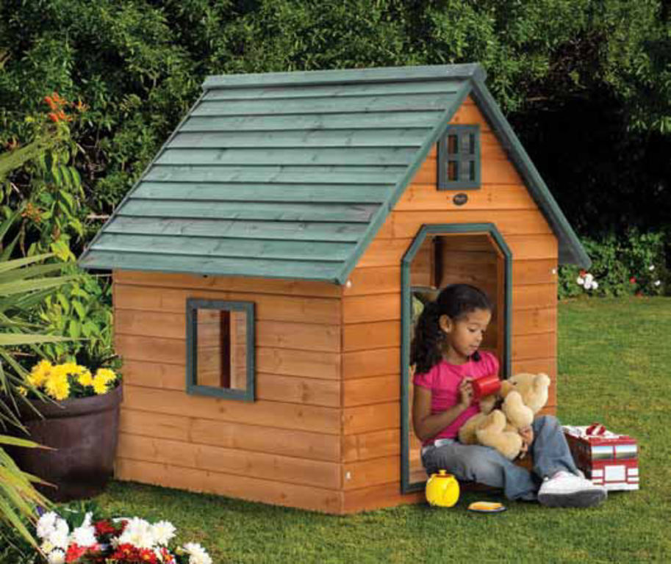
CARD B
Use the words given below to make questions. Ask your friend about his/her picture and listen to the answers.
1. What/see/picture?
2. How/look?
3. What/do?
4. How/may/feel?
5. Do/you/like? Why/why not?
Now, your friend will ask you questions about your picture. Answer his/her questions.
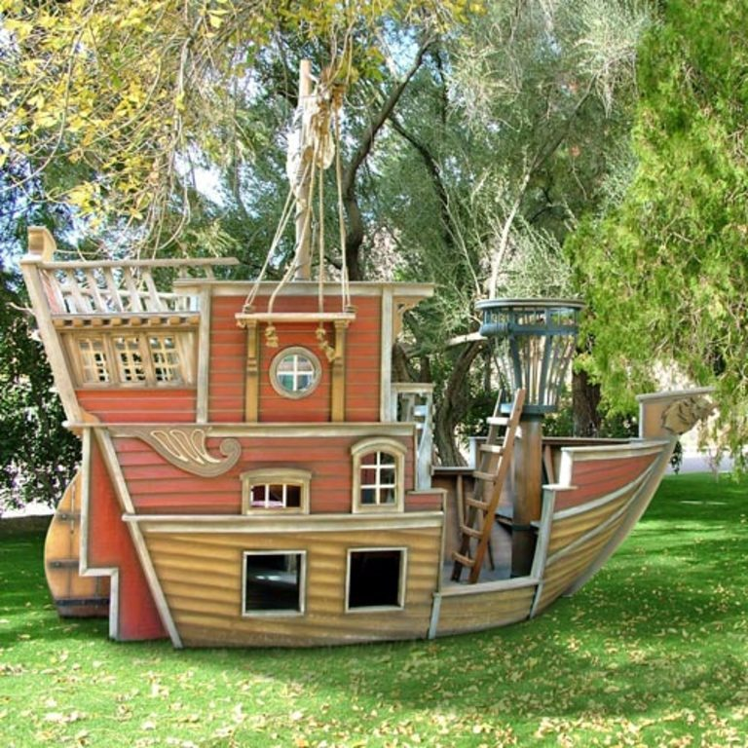
2. Now I’m going to ask you four questions about robots. Are you ready?
1. Do you like robots?
2. What will your favourite robot look like?
3. What will your favourite robot be able to do?
4. Do you want to have a robot in your house, and why?
2. Each of you will now receive a card. On the card there is a picture and clues for five questions. You should use the words to make questions and ask your friend. Your friend will answer the questions based on the picture he/she has.
CARD A
Use the words given below to make questions. Ask your friend about his/her picture and listen to the answers.
1. Who/see/picture?
2. Where/they?
3. What/they/do?
4. How/they/look?
5. Do/like? Why/Why not?
Now, your friend will ask you questions about your picture. Answer his/her questions.
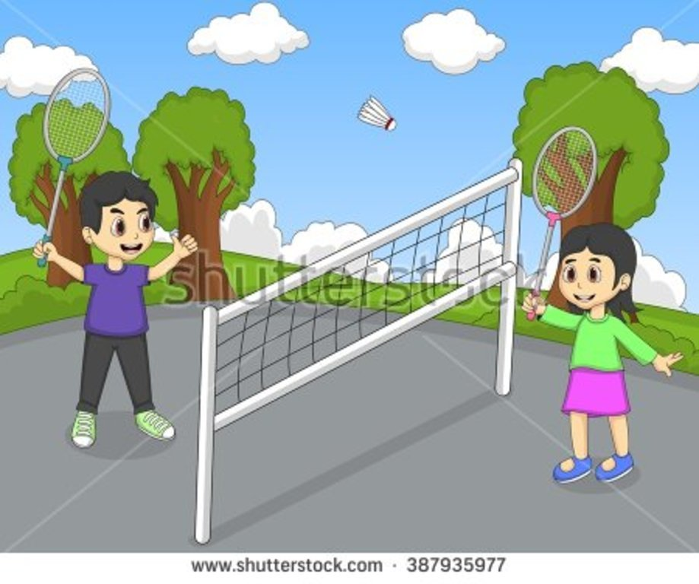
CARD B
Use the words given below to make questions. Ask your friend about his/her picture and listen to the answers.
1. Who/see/picture?
2. Where/they?
3. What/they/do?
4. How/they/look?
5. Do/like? Why/Why not?
Now, your friend will ask you questions about your picture. Answer his/her questions.

-- The end --

