ĐỀ CƯƠNG ÔN TẬP MÔN TIẾNG ANH 8- HKI
NĂM HỌC 2019- 2020
I. GRAMMAR
Chủ đề | Nội dung
Unit 1: Leisure activities | - Verbs of liking + gerunds  - Verbs of liking + to infinitives.
Unit 2: Life in the countryside | - Comparative forms of adjectives (review)  - Comparative forms of adverbs
Unit 3: People in Vietnam | - Questions: review  - Articles (some uses)
Unit 4: Our customs and traditions | - Modals : should and shouldn’t (review), have to
Unit 5: Festivals in Vietnam | - Simple sentences, compound sentences (review)  - Complex sentences
Unit 6: Folk tales | - Past simple (review)  - Past continuous
II. PRACTICE
A. READING:
I. Read the passage and complete it with the words given
traditions – means – according – however– therefore
The tradition of birthday parties started a long time ago. People thought there was a special danger from evil spirits on birthdays;(1) ___________, friends and family came together to bring good thoughts and wishes and even presents. There are some different (2) ______ in different countries around the world.
In Vietnam, on a child’s first birthday, family members put many things on the floor around the child for him or her to choose. (3) ______ to tradition, the first thing the child picks up will tell us his or her future job. In some countries, a 21st birthday cake is sometimes in a shape of a key. The key (4) _______ that the young person is now old enough to leave and build up to their own family at any time they want to. There is usually a special party on these birthdays.

II. Read the passage carefully then answer the questions below ( 1 pt):
Once upon a time there was a young girl called Cinderella. Cinderella was living happily with her family when her mother died. Her father married an evil widow with two daughters. Cinderella’s stepmother and two stepsisters mistreated her. She had to wear old clothes and work hard while the sisters wore fancy clothes and had fun. A good fairy helped Cinderella. She turned Cinderella’s old dress into a beautiful gown. Cinderella went to a party and a handsome prince politely invited her to dance with him. He fell in love with her and wanted to find out who she was. Cinderella left the party in a hurry and didn’t tell the prince her name. But she left a glass slipper, and the prince used that to find her. They got married and lived happily ever after.
1. Answer true (T) or false (F). (1 point)
 | True | False
a. Cinderella was living happily with her family when her mother died.
b. Her father married a kind woman.
c. Her stepmother and two stepsisters were very kind to her.
d. The prince got married to the girl who fitted the left glass slipper.
2. Questions:
1. What did Cinderella’s father do when his wife died?
2. How did Cinderella’s stepmother and two stepsisters treat her?
3. Who turned Cinderella’s old clothes into a beautiful gown?
4. What did the prince use to find Cinderella?
III. Choose the correct word A, B, C or D for each gap to complete the following passage :
Rice is (1)______by Vietnamese people every day. It often (2)______in tropical countries such as Vietnam, Thailand or Malaysia. The Chinese have also been growing rice for (3)______years. The seeds are planted in special beds to grow into young rice plants. Then they are taken to fields covered with muddy water called paddies. The fields of rice look very (4)______. After 3 or 5 months, the rice is ready to be picked. People often drain away water before colleting rice. Eating rice is a special action in the world. They don’t use spoons or forks to enjoy bowls of rice. (5)______, they use two short sticks known as chopsticks to put rice into their mouths. China and Vietnam are the two countries in which people use chopsticks very well.
1. A. used B. taken C. eaten D. boiled
2. A. grows B. keeps C. plants D. stays
3. A. thousands B. thousand C. thousand of D. thousands of
4. A. beauty B. beautiful C. beautifully D. the beauty
5. A. However B. Moreover C. Besides D. Instead
IV. Read the following passage and do the tasks below :
Tet holiday is celebrated on the first day of the Lunar New Year in Viet Nam. Some weeks before the New Year, the Vietnamese clean their houses and paint the walls. New clothes are bought for the occasion. One or two days before the festival, people make Banh chung, which is the traditional cake, and kinds of jam. On the New Year's Eve, the whole family gets together for the reunion dinner. On New Year morning, all the members of the family pay their respects to the elders by beautiful words. In return, they receive lucky money wrapped in red tiny envelopes. Then people go to visit the neighbors, friends and relatives.
A. Choose the best answer A, B, C or D to complete the sentences:
1. __________________days before the festival, people make Banh chung.
A. One B. Two C. Three D. One or two
2. People go to visit the__________________ .
A. neighbors and friends B. neighbors, a friend and relatives
C. neighbors, friends and relatives D. neighbor, friends and relatives
B. Answer the questions:
1. When is Tet holiday celebrated in Viet Nam?
2. What do they do on the New Year's Eve?
3. Who give lucky money wrapped in red tiny envelopes?
B. WRITING:
I. Rearrange the given words to complete the sentence.
1. festival/ in / Viet Nam / Tet / is / the / most / important /
2. because / they / can / Children / like/ Tet / receive / lucky / money /
II. Rewrite or combine the sentences, using the suggested words.
1. Mr Lam was very busy; however,he spent the whole day at the La Mat Village festival.
=> Although……………………………………………………………………………….
2. I love listening to music.
=> I fancy ……………………………………………………………………………
- You are advised not to wear shorts when going to pagodas.
=> You should not ………………………………………………………………………
4. My house is smaller than your house.
=> Your house .……….……….……….……….……….………………
III. Combine each pair of sentences to make one sentence, using the words given in brackets
1. We won’t hold the festival. It costs too much money. (IF)
=> ……………………………………………………………………………
2. The tortoise was running. The hare was sleeping. (WHILE)
=> ………… …………………………………………………………………
3. The girl worked hard. Her stepmother wasn’t happy. (ALTHOUGH)
=> ………….…………………………………………………………………
4. The Buffalo- fighting Festival took place in Do Son last Saturday. There were so many people. (BECAUSE)
=> ……………..………………………………………………………………
IV. Read the situation and complete the sentences with the right comparative form of the adverbs in brackets.
1. A lion can run 100km/hr while a horse can run 80km/hr. (fast)
=> A lion can run………………………………………………………………
2. They are both good at speaking English, but Hung speaks better than Nam. (badly)
=> Nam speaks English ………………………………………………………..
3. The Eagle team performed more successfully than the Tiger team. (successfully)
=> The Tiger team performed…………………………………………………..
4. A sports car goes faster than an ordinary car. (slowly)
=> An ordinary car goes………………………………………………………..
V. Write a paragraph about a fairy tale you have read. Write 80-100 words.
You should write about:
- What the story is about
- Who the main characters in the story are
- What happened in the story
- What the meaning of the story is
C. LISTENING:
I. Listen to Mai’s presentation and fill in the missing words. (1 point)
Today I’m going to tell you about the xoe dance, a (1)……………………. dance of the Thai ethnic group in Vietnam. Thai people have followed this spiritual tradition for generations.
The xoe dance expresses people’s working life and wishes for a happy and (2)……………………... life. It is performed in both public and private gatherings such as celebrations, festivals, or family reunions.
The xoe dance has more than 30 (3)………………………… based on the first six ancient forms. The most popular form is the xoe vong or “circle dance” because it expresses social unity. People young or old alike, join hands to make a circle around the fire and dance to the music. Besides the circle dance, there are dances with (4)…………………………. hats. paper fans or scarves.
Old people say they shouldn’t (5)……………with this tradition because it reflects Thai culture and lifestyle. As a Thai folk song goes, without the xoe dance, the rice won’t grow and people won’t get married.
II. Listen and decide whether these statements are true or false (1 point)
 | T | F
1. Saint Giong is worshipped for defending the Ming
2. The preparations for the festival begin two month beforehand .
3. The festival is held from the 6th to the 12th of the 4th lunar month.
4. There is a performance of quan ho singing when night falls.
5. This festival shows the love for our motherland and the preservation of our cultural heritage.
III. Listen to the conversation about living in the countryside in Japan. Circle A, B or C to answer each question.
1. | Where is Sam living now?
 | A. in England | B. in Japan | C. in Europe
2. | What does he like about the village?
 | A. the mountains | B. the ocean | C. the pollution
3. | How does he feel about the people in the village?
 | A. difficult | B. friendly | C. easy
4. | Which among these is true about Sam's attitude towards the weather in the village?
 | A. He likes it very much.
 | B. He thinks it is comfortable.
 | C. He hates it.
5. | What is the most unusual about the village in Sam's opinion?
 | A. There are many snakes.
 | B. All snakes are green.
 | C. Snakes like to stay in his office.
IV. Listen to the conversation between Jack and Nam about ethnic groups in Viet Nam. Fill each of the gaps with no more than THREE words or a number.
1. | Viet Nam has 54 ethnic groups __________.
2. | The Viet has the largest ___________.
3. | The Tay has a population of around _________.
4. | The Khmer has about ___________ people.
5. | Jack said that Viet Nam is a ___________.
D. TOPIC SPEAKING
Each of you will now receive a card. On the card there is a picture and clues for five questions. You should use the words to make questions and ask your friend. Your friend will answer the questions based on the picture he/she has.
TOPIC 1:
 | CARD A
 | Use the words given below to make questions. Ask your friend about his/her picture and listen to the answers.
1. | What/see/picture?
2. | Where/they?
3. | What/they/do?
4. | What/custom?
5. | What/meaning/custom?
Now, your friend will ask you questions about your picture. Answer his/her questions.
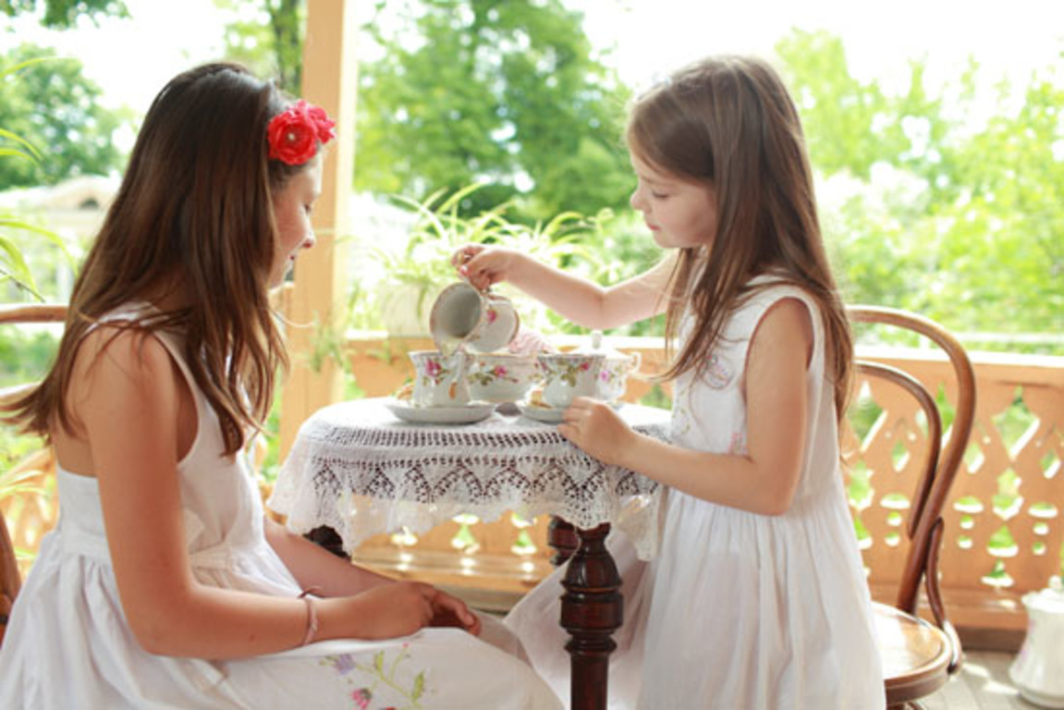
 | CARD B
 | Use the words given below to make questions. Ask your friend about his/her picture and listen to the answers.
1. | What/see/picture?
2. | Where/they?
3. | What/they/do?
4. | What/custom?
5. | What/meaning/custom?
Now, your friend will ask you questions about your picture. Answer his/her questions.
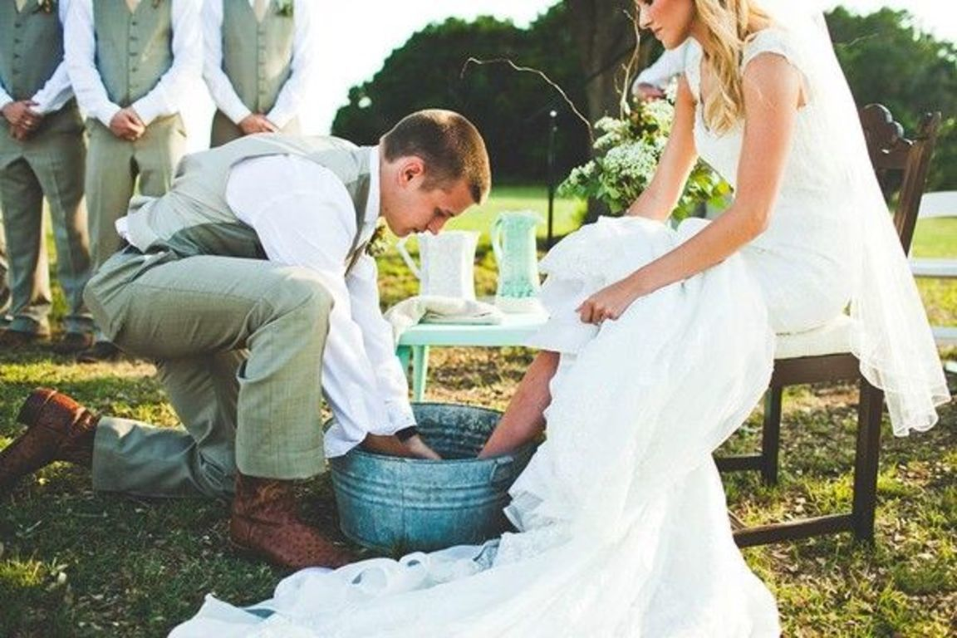

TOPIC 2:
 | CARD A
 | Use the words given below to make questions. Ask your friend about his/her picture and listen to the answers.
1. | What/character/in the photo?
2. | Where/character?
3. | What/the character/do?
4. | What/happen next?
5. | Do/you/like? Why/Why not?
Now, your friend will ask you questions about your picture. Answer his/her questions.
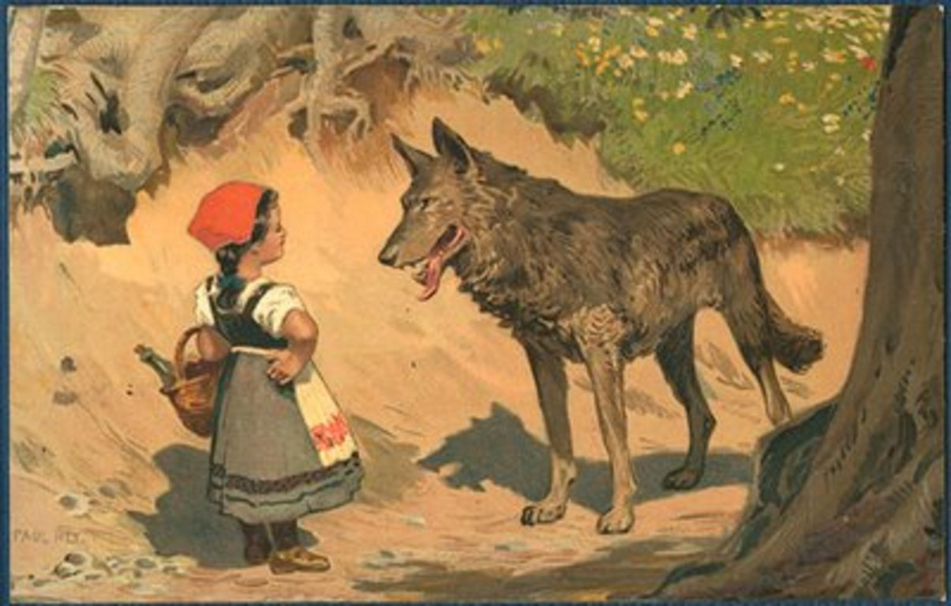
 | CARD B
 | Use the words given below to make questions. Ask your friend about his/her picture and listen to the answers.
1. | What/character/in the photo?
2. | Where/character?
3. | What/the character/do?
4. | What/happen next?
5. | Do/you/like? Why/Why not?
Now, your friend will ask you questions about your picture. Answer his/her questions.
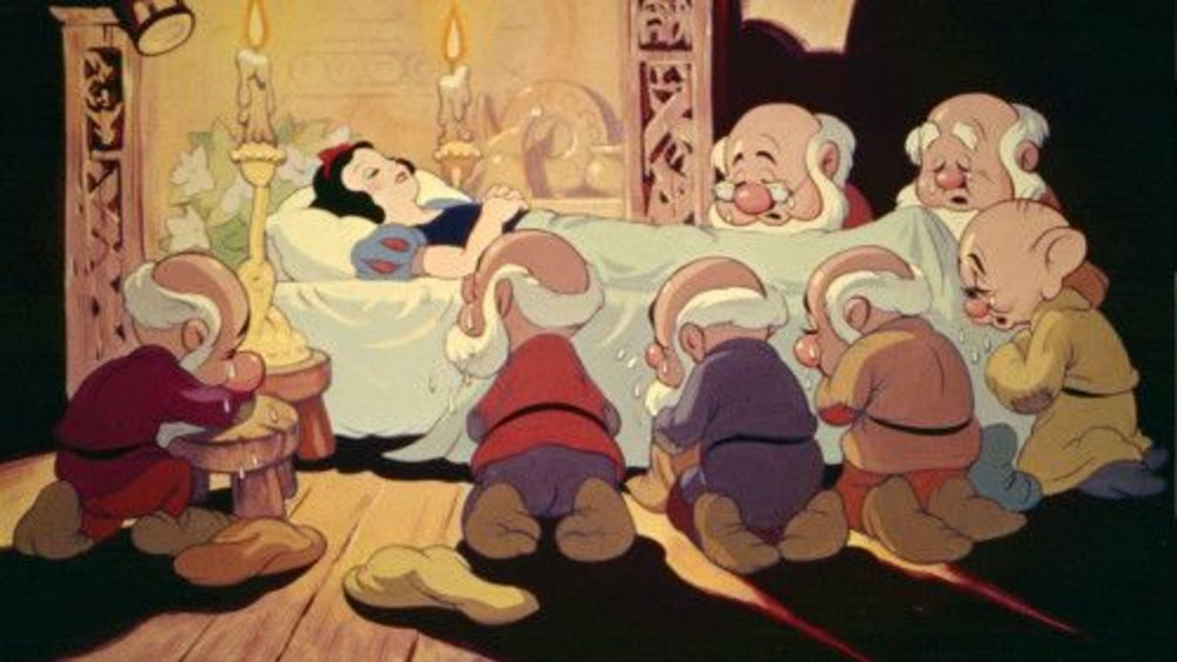
TOPIC 3:
 | CARD A
 | Use the words given below to make questions. Ask your friend about his/her picture and listen to the answers.
1. | What/see/picture?
2. | Where/picture/taken?
3. | What/do?
4. | How/feel?
5. | You/like? Why/Why not?
Now, your friend will ask you questions about your picture. Answer his/her questions.
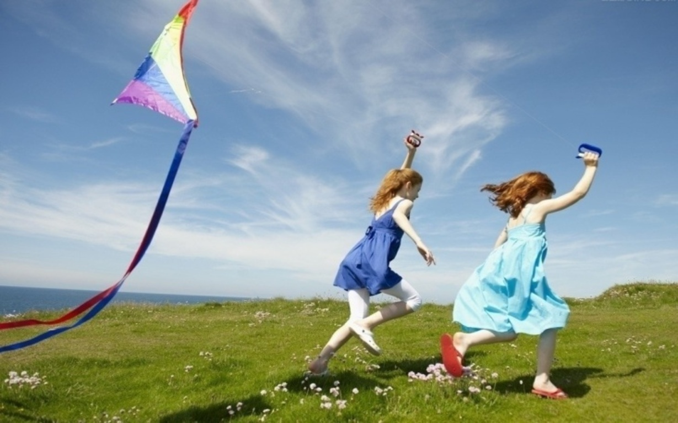
 | CARD B
 | Use the words given below to make questions. Ask your friend about his/her picture and listen to the answers.
1. | How many/see/picture?
2. | Where/they?
3. | What/do?
4. | How/may/feel?
5. | You/like? Why/Why not?
Now, your friend will ask you questions about your picture. Answer his/her questions.
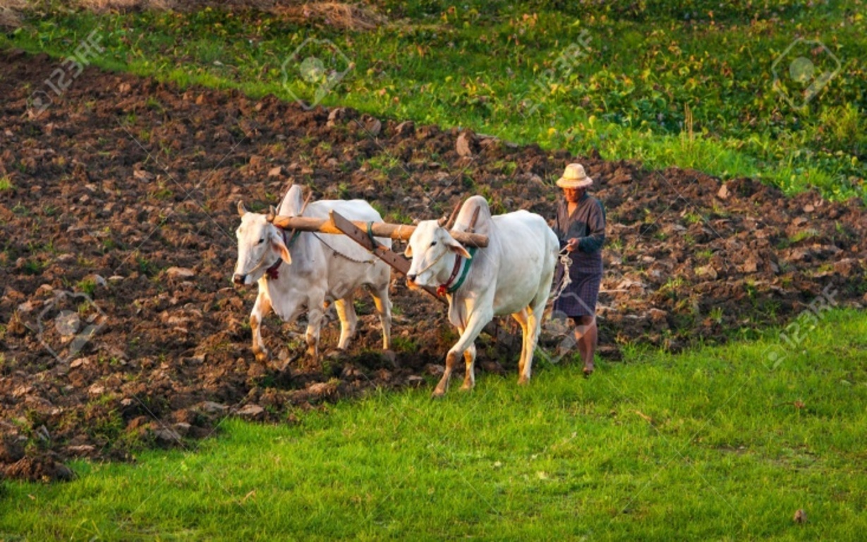

TOPIC 4:
 | CARD A
 | Use the words given below to make questions. Ask your friend about his/her picture and listen to the answers.
1. | How many/see/picture?
2. | Who/they?
3. | Where/they?
4. | What/they/doing?
5. | How/they/look?
Now, your friend will ask you questions about your picture. Answer his/her questions.
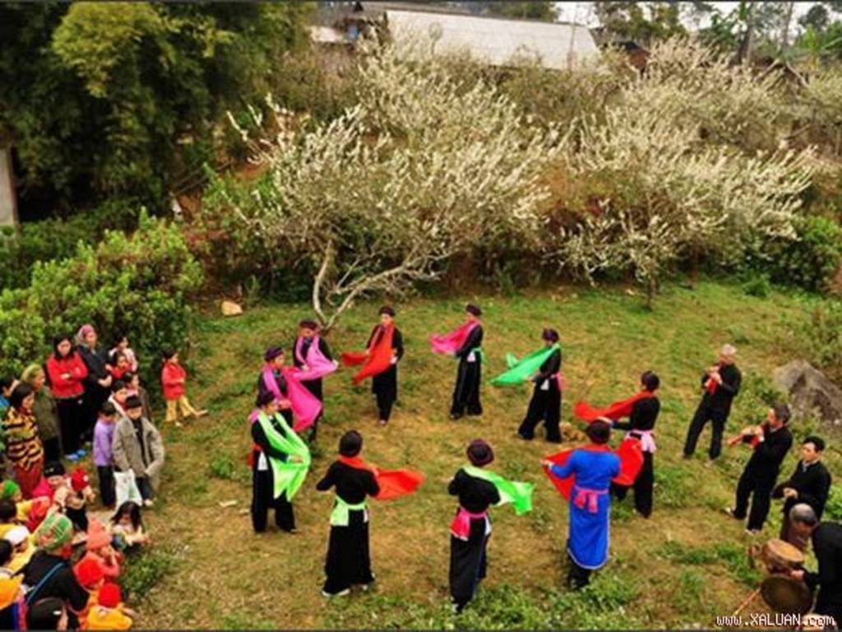
 | CARD B
 | Use the words given below to make questions. Ask your friend about his/her picture and listen to the answers.
1. | Who/see/picture?
2. | Where/they?
3. | What/see/around/?
4. | Which occasion/may/happen?
5. | How/may/feel?
Now, your friend will ask you questions about your picture. Answer his/her questions.
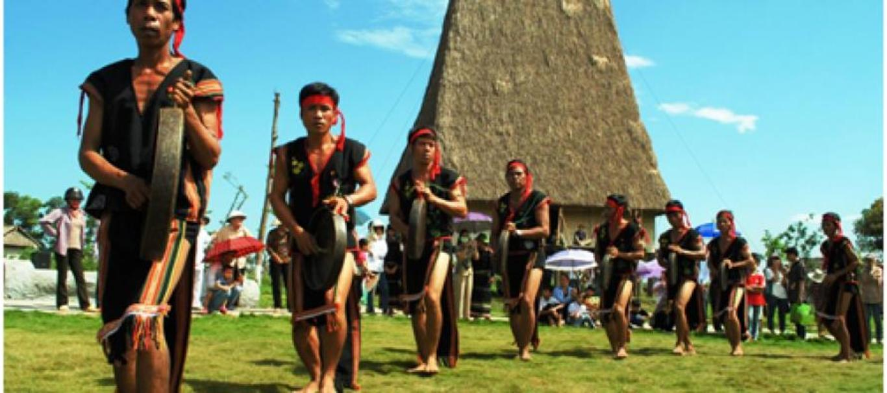

The end.

