**ĐỀ CƯƠNG ÔN TẬP HỌC KỲ 2 LỚP 8 CHƯƠNG TRÌNH THÍ ĐIỂM**

**NĂM HỌC : 2018-2019**

**A.GRAMMAR ( NGỮ PHÁP )**

**I. Conditional sentences type 1. (Câu điều kiện loại 1)**

**1. Form**

|  |  |
| --- | --- |
| IF CLAUSE ( Mệnh đề If ) | **MAIN CLAUSE ( Mệnh đề chính )** |
| Simple Present ( Thì hiện tại đơn ) **If + S + V (s/es)** | **Simple Future ( Thì tương lai đơn )**  **S + will/ won’t + V ( bare infinitive )**  **S+ can/must/ may/ might+ V( bare infinitive )** |

**Eg 1** If I **have** enough money, I **will buy** a big house.

( Nếu tôi có đủ tiền , tôi sẽ mua một ngôi nhà lớn ).

**Eg 2** If you **want** to pass the exam, you **must study** harder.

( Nếu bạn muốn thi đỗ , bạn phải học hành chăm chỉ hơn ).

**Eg 3** If she **doesn’t want** to be late, She **must get** up early.

( Nếu cô ấy không muốn bị muộn thì cô ấy phải dậy sớm ).

**2. Usage**

**- Câu điều kiện loại 1 là câu điều kiện diễn tả tình trạng có thật ở hiện tại hoặc tương lai.**

**Eg**  If you **learn** hard, you **will pass** the exam. Nếu bạn học chăm chỉ , bạn sẽ đỗ kỳ thi.

- Trong câu điều kiện loại 1, thì hiện tại đơn dùng trong mệnh đề If, còn thì tương lai đơn được dùng trong mệnh đề chính.

**Eg**

If the factory **continues** dumping poison into the lake, all the fish and other aquatic animals **will die**

Nếu nhà máy tiếp tục thải chất độc xuống hồ, thì tất cảloài cá và các sinh vật dưới nước sẽ chết.

**Chú ý Thì hiện tại đơn có thể được dùng trong mệnh đề chính để diễn tả một điều kiện luôn đúng**

**II. Conditional sentences type 2. (Câu điều kiện loại 2)**

**1.Form.**

|  |  |
| --- | --- |
| IF CLAUSE (Mệnh đề If ) | **MAIN CLAUSE ( Mệnh đề chính )** |
| **If +S + V-ed/2** If + S + were | **S + would / could/might + V(infinitive)** |
| **S + wouldn’t / couldn’t +V (infinitive)** |
|  |

**Eg 1** If I **became** rich , I **would spend** all my time travelling.

Nếu tôi giàu, tôi sẽ dành tất cả thời gian để đi du lịch.

**2.Usage**

**- Câu điều kiện loại 2 là câu điều kiện không có thật thường dùng để nói lên sự tưởng tượng của người nói. ( Điều kiện không thể xảy ra ở hiện tại hoặc tương lai ).**

If I **were** you, I **would buy** that bike.

Nếu tôi là bạn tôi sẽ mua chiếc xe đạp đó.

**Chú ý Trong mệnh đề không có thật ở hiện tại, chúng ta có thể dùng were thay cho was trong tất cả các ngôi trong mệnh đề If.**

**Eg** If I **were** you, I **would study** English hard.

Nếu tôi là bạn, tôi sẽ học Tiếng Anh chăm chỉ hơn.

**III. The present simple for future.( Thì hiện tại đơn mang ý nghĩa tương lai)**

**1. Form. (Cấu trúc)**

**a. Positive (Câu Khẳng định)**

|  |
| --- |
| I / We / You / They  + V( nguyên mẫu) |
| He / She / It + V (s/es) |
|  |  |  |  |  |  |

**Eg** I **go** to school every day.

My father often **watches** TV at 7 p.m

**b. Negative (Câu Phủ định)**

|  |  |
| --- | --- |
| I / We / You / They | don't (do not)+ V (nguyên mẫu) |
| He/ She / It | doesn't (does not) + V (nguyên mẫu) |

**Eg** I **don’t go** to school on Sundays.

He **doesn’t play** games on Saturdays.

**c. Question (Câu nghi vấn)**

|  |  |
| --- | --- |
| Do | I / We / You / They      + V (nguyên mẫu) |
| Does | He/ She / It + V (nguyên mẫu) |

**Eg Do** you **go** to school every day ?

**Does** he **play** football every afternoon?

**2. Usage (Cách dùng)**

- Thì hiện tại đơn diễn tả thói quen hằng ngày.

**Eg** He **gets up** at 5 o’clock in the morning.

-Thì hiện tại đơn diễn tả sự việc hay sự thật hiển nhiên**.**

**Eg** We **have** two children.

**Ngoài cách dùng ở trên , thì hiện tại đơn còn mang ý nghĩa tương lai khi nói về thời gian biểu, chương trình , lịch trình , … và trong các trạng từ chỉ thời gian cụ thể..**

**Eg** The plane **takes off** at 5.00 tomorrow morning.

**IV .The past perfect .( Thì quá khứ hoàn thành )**  
1.**Form**  
**a) Thể khẳng định (Affirmative form)       S + had + p.p**

Eg: I had left my wallet at home.

**b)  Thể phủ định (Negative form) s + hadn’t + p.p**

Eg: The house was dirty. They hadn’t cleaned it for weeks.

**c)  Thể nghi vấn (Interrogative form} Had + s + p.p?**

Eg: Where had he put his wallet?

**2. Cách dùng:** Thì quá khứ hoàn thành được dùng để diễn tả:

**a)    Hành động hoặc trạng thái đã xảy ra và đã kết thúc trước một thời điểm trong quá khứ.**

**By the end of last semester**, we had finished Book IV.

Cuối học kỳ trước, chúng ta đã hoàn thành quyển 4.

**Before his mother came back**, he had tidied up the whole room.

**b)   Hành động đã xảy ra và kết thúc trước một hành động quá khứ khác (hành động xảy ra trước dùng quá khứ hoàn thành, hành động xảy ra sau dùng quá khứ đơn).**

I had seen him ***before*** he saw me.

**c) Hành động đã xảy ra và kéo dài đến một thời điểm nào đó trong quá khứ.**

Ex: **By nine o'clock**, we had studied for three hours in the classroom.

Chúng tôi đã học 3 tiếng đồng hồ trong lớp từ lúc 9 giờ.

I had worked for several hours when he called. She told me that she had walked for two hours.

*** LƯU Ý:

***Dấu hiệu nhận biết:***

Trong câu thường có các từ: ***before(TRƯỚC KHI ), after(sau khi), when(khi), by the time(vào thời điểm), by the end of + time in the past …***

Ex: *When I **got** up this morning, my father ***had already left***.

***\**** *By the time* ***S. Past, Past Perfect***.

       By the time I **met** you, I ***had worked*** in that company for five years.

***\**** *S. Past* ***After*** *Past Perfect*

They **went** home **after** they **had eaten** a big roasted chicken.

(Họ về nhà sau khi đã ăn một con gà quay lớn.)

**After** I ***had bou***ght a new pen, I ***found*** my pen

**\*** *Past Perfect* ***Before*** S.past

She **had done** her homework **before h**er mother **asked** her to do so.   
 ***Before he arrived his office***, his secretary had gone out

**V.**  **PASSIVE VOICE** (THỂ BỊ ĐỘNG)

1. **CÂU BỊ ĐỘNG** (Passive sentences):

Câu bị động là câu trong đó chủ ngữ là người hay vật nhận hoặc chịu tác động của hành động.

Eg: (A) I asked a question.

→(P) : A question was asked by me. Một câu hỏi được hỏi bởi tôi.

**B. Cách chuyển từ câu chủ động sang câu bị động:**

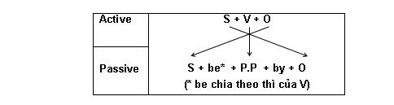

**\*  Thể khẳng định (Affirmative form) S + be + p.p (Past Participle) + (by + 0)**

Ex: The picture was painted by Tom.

               S be + p.p                  O

**\*  Thể phủ định (Negative form) S + be not + p.p + (by + 0)**

Ex: The picture was not painted by Tom.

       s be + p.p                                 o

**\* Thể nghi vấn (Interrogative form) Be + S + p.p + (by + 0)?**

Ex: Was the picture painted by Tom?

Be S             p.p          o

Động từ be ở đây phải phù hợp với chủ ngữ cũng phải thể hiện được thì cuar câu. Khi dịch nghĩa câu bị động, ta dịch là “bị, được” tùy vào câu, ngữ cảnh mà ta chọn nghĩa cho phù hợp.

**Câu bị động ở từng thì:**

|  |  |
| --- | --- |
| **TENSES** (Các loại thì) | **PASSIVES STRUCTURE**(**Cấu trúc bị động)** |
| **Present simple (Hiện tại đơn )**  I learn English. | **is/ are/ am + V.pp / Ved**  English is learned (by me). |
| **Present progressive ( QK Tiếp Diễn)**  She is reading the book. | **is/ are/ am + being + V.pp / V.ed**  The book is being read (by her). |
| **Past simple ( Quá khứ đơn)**  The little boy broke the glass. | **was / were + Vpp / Ved**  The glass was broken by the little boy. |
| **Past progressive ( QK Tiếp Diễn)**  The police were interrogating him. | **was/ were + being + V.pp / Ved**  He was being interrogated by the police. |
| **Present perfect ( QK hoàn thành)**  She has cooked the food. | **have/ has been + V.pp / Ved**  The food has been cooked (by her). |
| **Future simple ( Tương lai tiếp diễn )**  They will cover the road with a red carpet tomorrow. | **will be + V.pp / Ved**  The road will be covered with a red carpet tomorrow. |
| **Future progressive**  I will be holding the wedding party ưi Ha. Noi next month. | **will be being + V.pp / Ved**  My wedding party will be being held in Ha Noi next month. |

#### VI. Future continuous .( THÌ TƯƠNG LAI TIẾP DIỄN)

**1.Form**

(+) S + will/ shall + be + V-ing

Ex: I / we shall be working

You / he, she , it, they will be + working

(-) S + won’t / shan’t + be + V-ing

Ex: I / we shan’t be working

You / he, she , it, they won’t be + working

(?) Shall + S + be + V-ing…?

**Ex: Shall I / We + be working?**

**Will you/ he/ she /it / they be working?**

**2.Usage:**

Thì tương lai tiếp diễn được dùng để:

- .Diễn tả một hành động kéo dài trong một thời gian nào đó ở tương lai

Ex: By this time torromow, They will be playing volleyball

- .Diễn tả một hành động sẽ xảy ra trong tương lai mà thời điểm không cần xác định

ex:I’ll be visting her tomorrow

**VII. Verb to –Infinitive**

Nếu chúng ta muốn tuân theo một động từ với một hành động khác , chúng ta phải sử dụng một danh động từ hoặc một động tử (to infinitive)

Verb + to-infinitive ( V + to V)

Ex: I want to go to the market.

**- Một số động từ thông thường tuân theo bởi to – Ininitive**

Choose, decide, plan, love, hate, prefer, try, want , need

**\* Note:một số động từ như: love, hate, prefer có thể tuân theo cả hai : V-ing và to – V mà không đổi nghĩa**

**VIII. QUY TẮC ĐÁNH DẤU TRỌNG ÂM**

**1.Đánh dấu nhấn âm trên từ có âm kết thúc là -ic và -al**

*Khi thêm một hậu tố ***-ic*** vào một từ thì sẽ làm từ đó thay đổi cách nhấn âm. Ta sẽ nhấn ***âm trước ngay hậu tố thêm vào. Hay nói cách khác ta sẽ nhấn âm ngay trước hậu tố -ic của một từ.***

Ex: atom —► ***a’tomic; po' etic***

*Khi thêm một ***hậu tố -al vào một từ thì sẽ không làm thay đổi cách nhấn âm của từ đó.***

Ex: 'music ***—> 'musical***

Lưu ý: Nếu một từ có thể dùng cả hai hậu tố: một hậu tố là -***ic và một hậu tố khác là -al, thì giữa hai từ này có cùng một cách*** nhấn âm.: Ex: e'conomy ***—► economic —> economical***

botanic ***—►***  bo'tanic ***—►***  bo’tanical

**2.Các từ có tận cùng là: -ese, -ee, -eer, -oo, -oon, -ique, -ed, -esque thì trọng âm rơi** vào những từ này:

*Ex. Vietna'mese, employ'ee,*  adop’tee, addre’ssee, intervi’ew, Cantonese, Taiwan’ese

**3. *Những từ có 3 âm tiết trở lên thì trọng âm (nhấn âm) rơi vào âm tiết thứ ba từ phải sang trái.***

Ex: ge'ography

**Chú ý: Đối với từ mà tận cùng *-logy và – graphy* thì dấu nhấn được nhấn vào âm thứ ba kể từ cuối trở lên.**

Technology***—►***Technology Biology ***—►*** bi'ology geography***—►***ge'ography

photography ***—►***pho'tography apology ***—►***a'pology     ecology ***—►*** e'cology

**4. Những từ tận cùng là -ity and -itive**

Những từ có tận cùng là-ity and -itive , thì trọng âm đứng trước hậu tố

Ex: ‘possitive, oppor’tunity.

**XIII. CAUSE VÀ EFFECT**

|  |  |
| --- | --- |
| **Cause** | **Effect** |
| **1. Because /Since + Clause**  Ex: Because the water is polluted, the fish are dead. | **so + clause**  Ex: The water is polluted, so the fish are dead |
| **2. Due to /because of + sthing**  Ex: The fish is dead because of the pulluted water. | **to cause sth / to lead to sth/ to result in sth**  Ex: The polluted water, causes/ resukt in the death of fish. |
|  | **to make sbody/sth do sth**  **Ex: the poluted water makes the fish die .** |

**B. EXERCISE**

**I. LISTENING**

**1. Listen to Son and Peter talking about the most important inventions of the 21th century. Fill each of the gaps with no more than THREE words and/or a number. You will listen TWICE.**

|  |  |  |  |
| --- | --- | --- | --- |
|  | **Facebook** | **Youtube** | **Google Driverless Car** |
| Year of invention | (1) ______ | (2) ______ | 2012 |
| Usage | It (3) ______  1.6 billion people around the world. | World most popular (4) _______. | Change the way people (5) ______ the city. |

**2. Listen to the instructions on what to do in an earthquake. Decide if the statements are true (T) or false (F). Circle T or F.**

|  |  |  |
| --- | --- | --- |
| 1. If you are indoors, stay away from windows. | T | F |
| 2. If you are indoors, try to run away as far as possible. | T | F |
| 3. If you are driving, get out of the car immediately. | T | F |
| 4. If you are trapped, keep shouting loudly until helpers come. | T | F |
| 5. If you are trapped, you should make sound on a pipe or wall so helpers can find you. | T | F |

**3. Listen to a school teacher talking about cyber-bullying. Fill each of the gaps with no more than TWO words. You will listen TWICE.**

The Internet is said to be one of the most amazing (1)____________ that humans have made. Since its appearance, the Internet has been so popular that nearly everyone uses it or knows about it. However, the Internet can be a scary place, especially because of cyber-bullying. Open any (2)____________ these days and you will see a story about this cyber-bullying. It’s a really nasty and growing problem. Cyber-bullies are real cowards. They hide behind their computers and scare people, send them hate mail or threaten them. Even worse is when they (3) ____________ pictures of their victims online. I have a friend who had a bad time at the hands of a cyber-bully. The cyber-bully (4)____________ lots of gossips and lies on the Internet. My friend’s reputation was badly damaged. You may wonder how cyber-bullying starts at school. Many schoolchildren physically bully others in class and then continue doing it online. Their victim isn’t safe anywhere. It is high time we (5) ____________ to stop cyber-bullying.

**III.READING**

**Question I Read the passage and choose the correct answer A, B, C or D.**

Environmental pollution is a term that (1)______ to all the ways by which man pollutes his surroundings. Man dirties the air with (2)______ gases and smoke, (3)_____ the water with chemicals and other substances, and damages the (4)_____ with too many fertilizers and pesticides. Man also pollutes his surroundings (5)_____ various other ways. For example, people ruin natural beauty by (6)_____ junk and litter on the land and in the water.

Environmental pollution is one of the most serious problems facing mankind today. Air, water and soil are necessary to the (7)_____ of all living things. Badly polluted air can cause illness, and (8)_____ death. Polluted water kills fish and other (9)_____ life. Pollution of soil reduces the amount of land that is available for growing food. Environmental pollution also brings ugliness to man’s (10)_____ beautiful world.

1. A. means B. refers C. provides D. reduces

2. A. thick B. natural C. exhaust D. influent

3. A. purifies B. pumps C. sprays D. poisons

4. A. soil B. forests C. streets D. beaches

5. A. on B. in C. by D. with

6. A. spoiling B. leaving C. scattering D. gathering

7. A. survival B. environment C. development D. growth

8. A. so B. ever C. too D. even

9. A. animal B. marine C. human D. plant

10. A. nature B. natural C. naturally D. natured

**Question II Read the passage and answer the questions.**  
Visual pollution has a greater effect on people than you may think. I remember when I went to a big city, I was really scared because so much graffiti on the buildings' wall. Then I looked up, and I saw a lot of power lines over my head. Although they were not dangerous, I still felt unsafe since I thought they might fall down. These things prevented me from enjoying the beautiful sights of the city.  
I also remember the time when I was a student at a university. Once I was so busy with my assignments that I did not tidy my room for two weeks. Looking at the messy room caused me so much stress that I did not want to study. Then I decided to clean the room and put my thing in their proper places. I also bought a small plants and placed it in a corner of the room. These simple actions increased my motivation and helped me to focus on my learning.

**Questions.**

1.How did the author feel when she saw the power lines?

………………………………………………………………………………………………….

2.Why did she have that feeling?

……………………………………………………………………………………………………

3. What was she busy with?

……………………………………………………………………………………………………

4. What happened when she looked the messy room?

……………………………………………………………………………………………………

5. What did she do for her room?

……………………………………………………………………………………………………

**III. Complete the sentences with words/ phrases from the**

**IV. Read the passage and answer these questions below:**

England is not a large country. No town in England is very far from the sea, and many English families spend their summer holidays at the seaside. There are no high mountains in England, no very long rivers and very large forests.

There are many towns in England. No town is very far from another. The English countryside between the towns is like a carpets of many colors. In Spring and summer, the fields, meadows and forests are light green or dark green, and the gardens are green , red, blue, yellow and white with flowers.

**Questions**

1.Is England a large country?

..................................................................................................................................................

2. Where do many English families spend their summer holidays?

..................................................................................................................................................

3. Are there many towns in England?

..................................................................................................................................................

4. What is the English countryside like?

..................................................................................................................................................

**V. Read the passage and do the tasks that follow**

Alaska is perhaps the most amazing state in the USA. It has coastlines facing both the Arctic Ocean and the Pacific Ocean. This state has an incredible three million lakes. That’s four lakes per person living there.

Many cities in Alaska cannot be reached by road, sea, or river. The only way to get in and out is by air, on foot, or by **dogsled**. That’s why Alaska has the busiest sea airport in the world, Lake Hood Seaplane Base. Nearly two hundred floatplanes take off and land on the water of this airport every day. It is a really fun scene to watch.

Alaska is called the land of Midnight Sun because in summer, the sun does not set for nearly three months. But in winter the sun stays almost unseen.

All Alaskans take special pride in their beautiful and unique state.

1. Alaska ___________.

**A.** is another name for the USA

**B.** is an island in the Pacific Ocean

**C.** has coastlines facing both the Arctic Ocean and the Pacific Ocean

2. Which statement below is NOT CORRECT?

**A.** In Alaska, the number of lakes is bigger than that of people.

**B.** There is one lake for each person living there.

**C.** Alaska has an incredibly high number of lakes.

3.Which method below can always be used to reach a place in Alaska?

**A.** by air **B.** by road **C.** by river

4. In Alaska we can always see the sun ___________.

**A.** in winter **B.** in summer **C.** every month of the year

**VI>Read the text about Alexander Graham Bell and do the tasks**

Alexander Graham Bell is widely known as inventor of the first telephone. He was born on March 3rd, 1847 in Edinburgh, Scotland. When he was 23, Bell emigrated to Canada with his parents and the next year moved to the United States to teach deaf-mute children. With his colleague Thomas Watson , Bell worked very hard on the experimentation to invent devices such as the *harmonic telegraph* ( used to send multiple messages over a single wire) and *phonautograph* ( used to draw the shape of the sound waves. The first telephone communication was said to have happened between Bell and Watson in 1876 while Bell was at one end of the line, and Watson worked on the telephone in other room. The first transmitted words were, ‘ Mr Watson, come here . I want to see you’

**a. Decide if the statements are T or F**

1.Alexander Graham Bell is Scottish.

2.He spent all his life in Canada

3.He worked with the deaf when he moved to the USA

4.He wanted to create a device that can transmit human voice

5.He was able to succeed right from the first experiment

6.He worked on his inventions all by himself

**b. Answer the questions**

1.What is Bell ‘s ‘harmonic telegraph’ ?

2.What is Bell ‘s ‘phonautograph’

3.When did the first communication over happened and how did it happen?

**VII.Read the text and do the tasks**

Almost a hundred thousand people were killed and half a million homes destroyed as a result of an earthquake in Tokyo in 1923. The earthquake began a minute before noon when the habitants of Tokyo were cooking their midday meals. Thousand of stoves were overturned as soon as the earth began to shake . As a result, small fires broke out everywhere and quickly spread. The fire engines were prevented from going to help because many of the roads had cracked open. It was impossible to use fire fighting equipment as most of the water pipes had burst. Consequently, over ninety percent of the damage was caused by fire rather than by the collapse of buildings

***\* These sentenses are T (true ) or F ( false )***

*1, A hundred thousand people were killed in Tokyo in 1923 because of an earthquake*

*2. The earthquake began a minute before midnight*

*3. The fire engines were prevented from going to help because most of the water pipes had burst*

*4. Over ninty percent of the damage was caused by fire*

**III. WRITING**

**Question I.Write a conditional sentence type 2 for each situation, as in the example.**

**Viết loại câu điều kiện loại 2 cho mỗi tình huống , như trong ví dụ.**

1.People throw rubbish in the street.The street doesn’t look attractive.

If people didn’t throw rubbish in the street, it would look attractive.

2.There are so many billboards in our city. People can not enjoy the view.

If ………………………………………………………………………………………………….

3.There is so much light in the cityat night.We can not see the stars clearly.

If …………………………………………………………………………………………………

4.We turn on the heater all the time. We have to pay three million dong for electricity a month.

If …………………………………………………………………………………………………

5.The karaoke bar makes so much noise almost every night. The residents complain to its owner.

If …………………………………………………………………………………………………

6.She has a headache after work every day.She works in a noisy office.

If ………………………………………………………………………………………………….

**II. Rewrite the sentences below without changing their original meaning.**

1. Radioactive pollution is very dangerous. It can cause abnormal growth. [**since**]

1. Leaves are damaged. The tree cannot get enough food energy to stay healthy. [**because**]

1. I don’t have much money now, but I want to buy a house in PhuCuong.

If

1. Light pollution happens. There is a change in animals’ living patterns.

If

1. Acid rain is dangerous. Trees’ leaves are damaged. [**because of**]

1. The Walt Disney Studios, the famous movie company, has produced hundreds of cartoons for children.

Hundreds of cartoons for children

**III Rewrite the following sentences so that the second sentence means the same as the first one.**

1. Scientists have invented new devices to help people live a longer life.

New devices……………………………………………………

1. I don’t have enough time , so I can’t go on holiday this summer.

If …………………………………………………………………………..

3/The man had a broken leg. He tried to save his wife.-

🡪In spite of………………………………………………………………………………………

4. I can’t tell you because I don’t know the answer.

-🡪If ………………………………………………………………………………………………

5. They will do the test well. They will review them all hard.

>If…………………………………………………………………………………………………

6. The rescue workers evacuated the villagers in the raged flood to the safe place last night.

The villagers in the raged flood………………………………………………………..

7. The students will provide aids for the homeless people tomorrow.

>Aids……………………………………………………………………………………………

8. The people will protect the environment now. The environment will be nice

🡪If………………………………………………………………………………………………

9. They don’t have a map, so they get lost 🡪If………………………………………………………………

10. The storm destroyed many houses in this village last week.

-->Many houses…………………………………………………………………………

11. Did they give food to homeless people last year ?-->Was……………………………………………

12.Although the weather was bad,the fooball match was not canceled.

-->Despite……………………………………………………………………………………

13. The people will protect the environment now. The environment will be nicer

🡪If…………………………………………………………………………………

14. They don’t have a map, so they get lost-🡪If………………………………………………………………

15. The storm destroyed many houses in this village last week.

-->Many houses………………………………………………………………………………

16.Many rivers and lakes are poisoned. Factories produce waste and pour it into rivers and lakes. (because)………………… ……………………………………………………………

17. Plastic bags are a major source of waste. We should not throw plastic bags everywhere.

(so) ……………………………………………………………………………

18. We won’t hold the festival. It costs too much money.

(IF)=> …………………………………………………………………………………………

19. The tortoise was running. The hare was sleeping.

(WHILE) ……………………………………………………………………………

20. The girl worked hard. Her stepmother wasn’t happy.

(ALTHOUGH) ……………………………………………………………………………

**IV. SPEAKING**

**1. Now I’m going to ask you FOUR questions about natural disasters. Are you ready?**

 1. Have you ever seen a natural disaster?  
2. What can floods cause?  
3. Have you ever heard about a natural disaster?  
4. What should a person do when there is an earthquake?

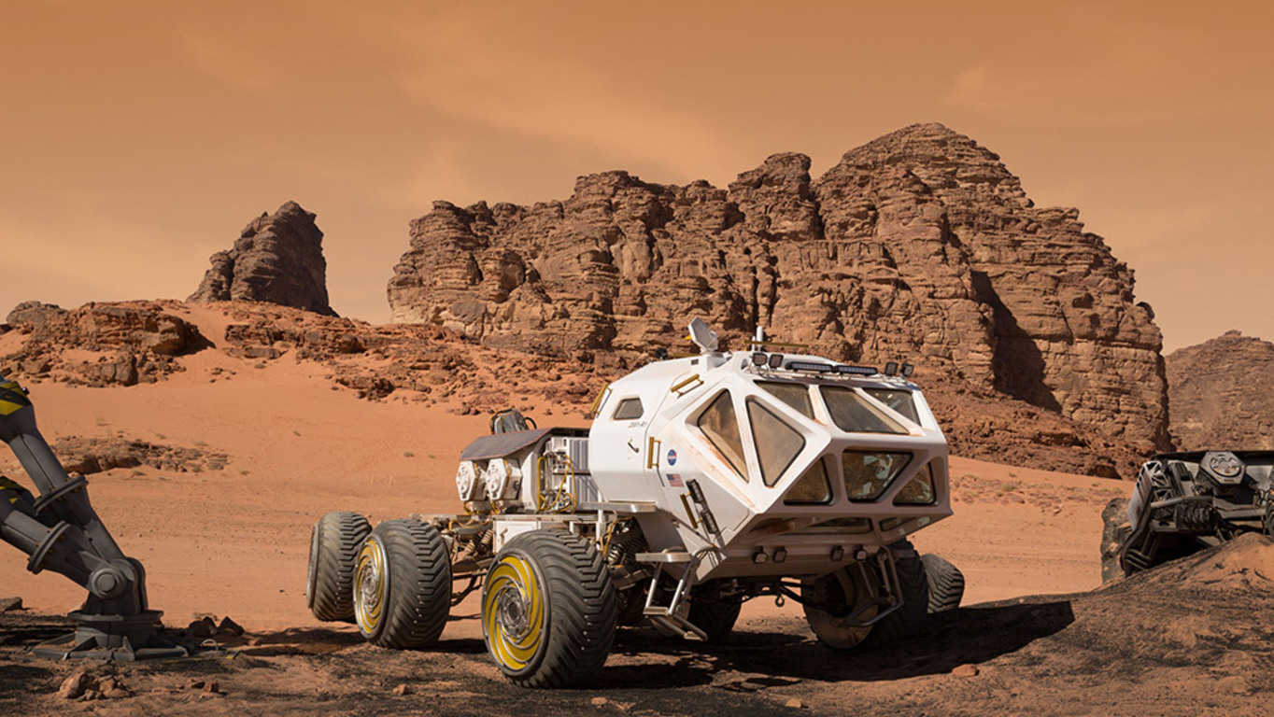**2. Each of you will now receive a card. On the card there is a picture and clues for four questions. You should use the words to make questions and ask your friend. Your friend will answer the questions based on the picture he/she has.**

**Card A**  
Use the words given below to make questions. Ask your friend about his/her pictures and listen to the answers.  
1. Where/picture/take?  
2. What/see?  
3. What/do?  
4. What/special?

Now, your friend will ask you questions about your picture. Answer his/her questions.  
  
  
  
**CARD B**  
Use the words given below to make questions. Ask your friend about his/her pictures and listen to the answers.  
1. Where/picture/take?  
2. What/place/look/like?  
3. What/see?  
4. What/do?  
Now, your friend will ask you questions about your picture. Answer his/her questions.  
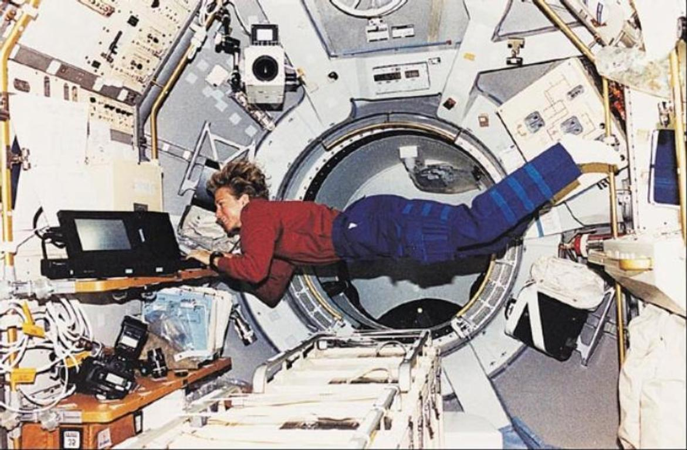

**2. Each of you will now receive a card. On the card there is a picture and clues for five questions. You should use the words to make questions and ask your friend. Your friend will answer the questions based on the picture he/she has.**

**Card A**  
Use the words given below to make questions. Ask your friend about his/her picture and listen to the answers.

|  |
| --- |
| 1. What/see/picture? |
| 2. What/they/do? |
| 3. How/look? |
| 4. What/country? |
| 5. What/come/for? |

Now, your friend will ask you questions about your picture. Answer his/her questions.  
  
**CARD B**  
Use the words given below to make questions. Ask your friend about his/her picture and listen to the answers.

|  |
| --- |
| 1. What/see/picture? |
| 2. What/they/do? |
| 3. How/look? |
| 4. What/relationaship? |
| 5. Where/they? |

Now, your friend will ask you questions about your picture. Answer his/her questions.  
